
CONFIDENTIAL CS/NOV 2026/CSC429

UNIVERSITI TEKNOLOGI MARA FINAL EXAMINATION

COURSE
COURSE CODE
EXAMINATION TIME
COMPUTER ORGANIZATION AND ARCHITECTURE

CSC429
NOVEMBER 2026
3 HOURS

INSTRUCTIONS TO CANDIDATES

- This question paper consists of two (2) parts: PART A (10 Questions) PART B (1 Question)

- Answer ALL questions in the Answer Booklet. Start each answer on a new page.

- Do not bring any material into the examination room unless permission is given by the invigilator .
- Please check to make sure that this examination pack consists of: i) the Question Paper
  - an Answer Booklet - provided by the Faculty

- Answer ALL questions in English.

DO NOT TURN THIS PAGE UNTIL YOU ARE TOLD TO DO SO

This examination paper consists of 5 printed pages.

PART A (80 MARKS)
Answer ALL questions in this part.
QUESTION 1 (5 marks)
Draw and label accordingly the complete machine cycle.
QUESTION 2 (5 marks)
The advancement of technology through different computer generations has focused on
improving performance, speed, and efficiency. From vacuum tubes in the first generation to
modern Al-powered systems, each generation introduced faster processing, smaller
components, and greater reliability.
- Name the inventor of the following devices:
- Mechanical Calculating Machine
- Analytical Machine
iiD
IAS Machine
- Why are the machines of later computer generation designed for general purposes instead
of the eadier computer generation that is more specific in function?
QUESTION 3 (5 marks)
Solve the following equation of -56s + A3H using 1's and 2's complement method. Show your
complete workflow.
QUESTION 4 (5 marks)
The availability of personal computers (PCs) impacted daily life, business, and society.
Computing became affordable and accessible to individuals and small businesses, allowing
modern communication and information sharing. It boosts work productivity by automating
tasks and better data processing.
- In which computer generation that the PC was first introduced?
- State the name of the first commercially available computer.
- What kind of interface was available when the PC was first introduced?
- Discuss the key factor that makes the personal computer portable.
QUESTION 5 (10 marks)
- Rank the following memory types based on price ranging from the cheapest to the most
expensive.
Cache, tape back-up, register, hard drive
- Discuss ONE (1) benefit of cache memory.
- Differentiate between write through and write back mechanisms in order to store data in
cache.
QUESTION 6 (10 marks)
- Complete the taxonomy of parallel processor architecture illustrated in Figure 1.
- Discuss TWO (2) disadvantages of symmetric multiprocessor (SMP).
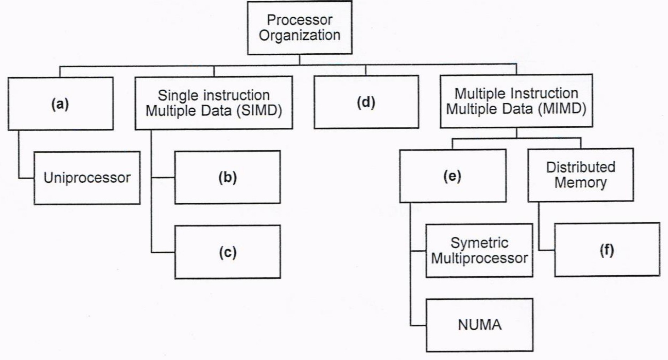
Figure 1: Taxonomy of Parallel Processor Architecture
QUESTION 7 (10 marks)
Processor contains a number of registers used for temporary storage of data. Describe FIVE
(5) types of registers.
QUESTION 8 (10 marks)
- Convert -27.1562510 to a floating-point number in IEEE single precision format in
hexadecimar varue form. show your comprete workflow.
- Convert 4'l E18O00n in IEEE single-precision floating-point number to decimal value form.
Show your workflow.
QUESTION 9 (10 marks)
- Define interrupt.
- Describe TWO (2) different types of interrupt.
- Discuss ONE (1) advantage and ONE (1) disadvantage of interrupt
QUESTION 10 (10 marks)
- Identify the correct concept of computer organization or architecture in the following
scenario.
Scenario
Concept
Deals with the logical aspects of the
system, including instruction sets,
data formats, and addressing modes.
Defines the functionality, capabilities,
and programming model.
Concerned with how the computer
will execute the tasks and implement
the functions.
Involves the hardware layout, circuits,
control signals, memory access, and
timing.
- Describe THREE (3) CPU registers involved in data processing, such as arithmetic
operations.

PART B (20 MARKS)
Answer the question in this part.
QUESTION 11 (20 marks)
Question 1 is based on Figure 2 and Table 1.
write an appropriate program using correct assembly language notations to compute the
equation snbwn in Figure 2 using instructions for zero-address, one-address, and three-
address. The available instructioni are provided in Tabte 1. The register labeled A, B, C, and
D are fixed, white registers x, y, and z can be used temporarily. The final answer must be
stored in register z.
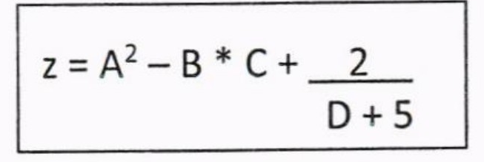
Figure 2
Table 1: Machine instruction
Zero-address | One-address | Three-address
PUSH p | LOAD p | ADD (p,q,r)
POP p | STOR p | suB (p,q,r)
ADD | ADD p | MUL (p,q,r)
SUB | SUB p | DIV (p,q,r)
MUL | MUL p
DIV | DIV p

